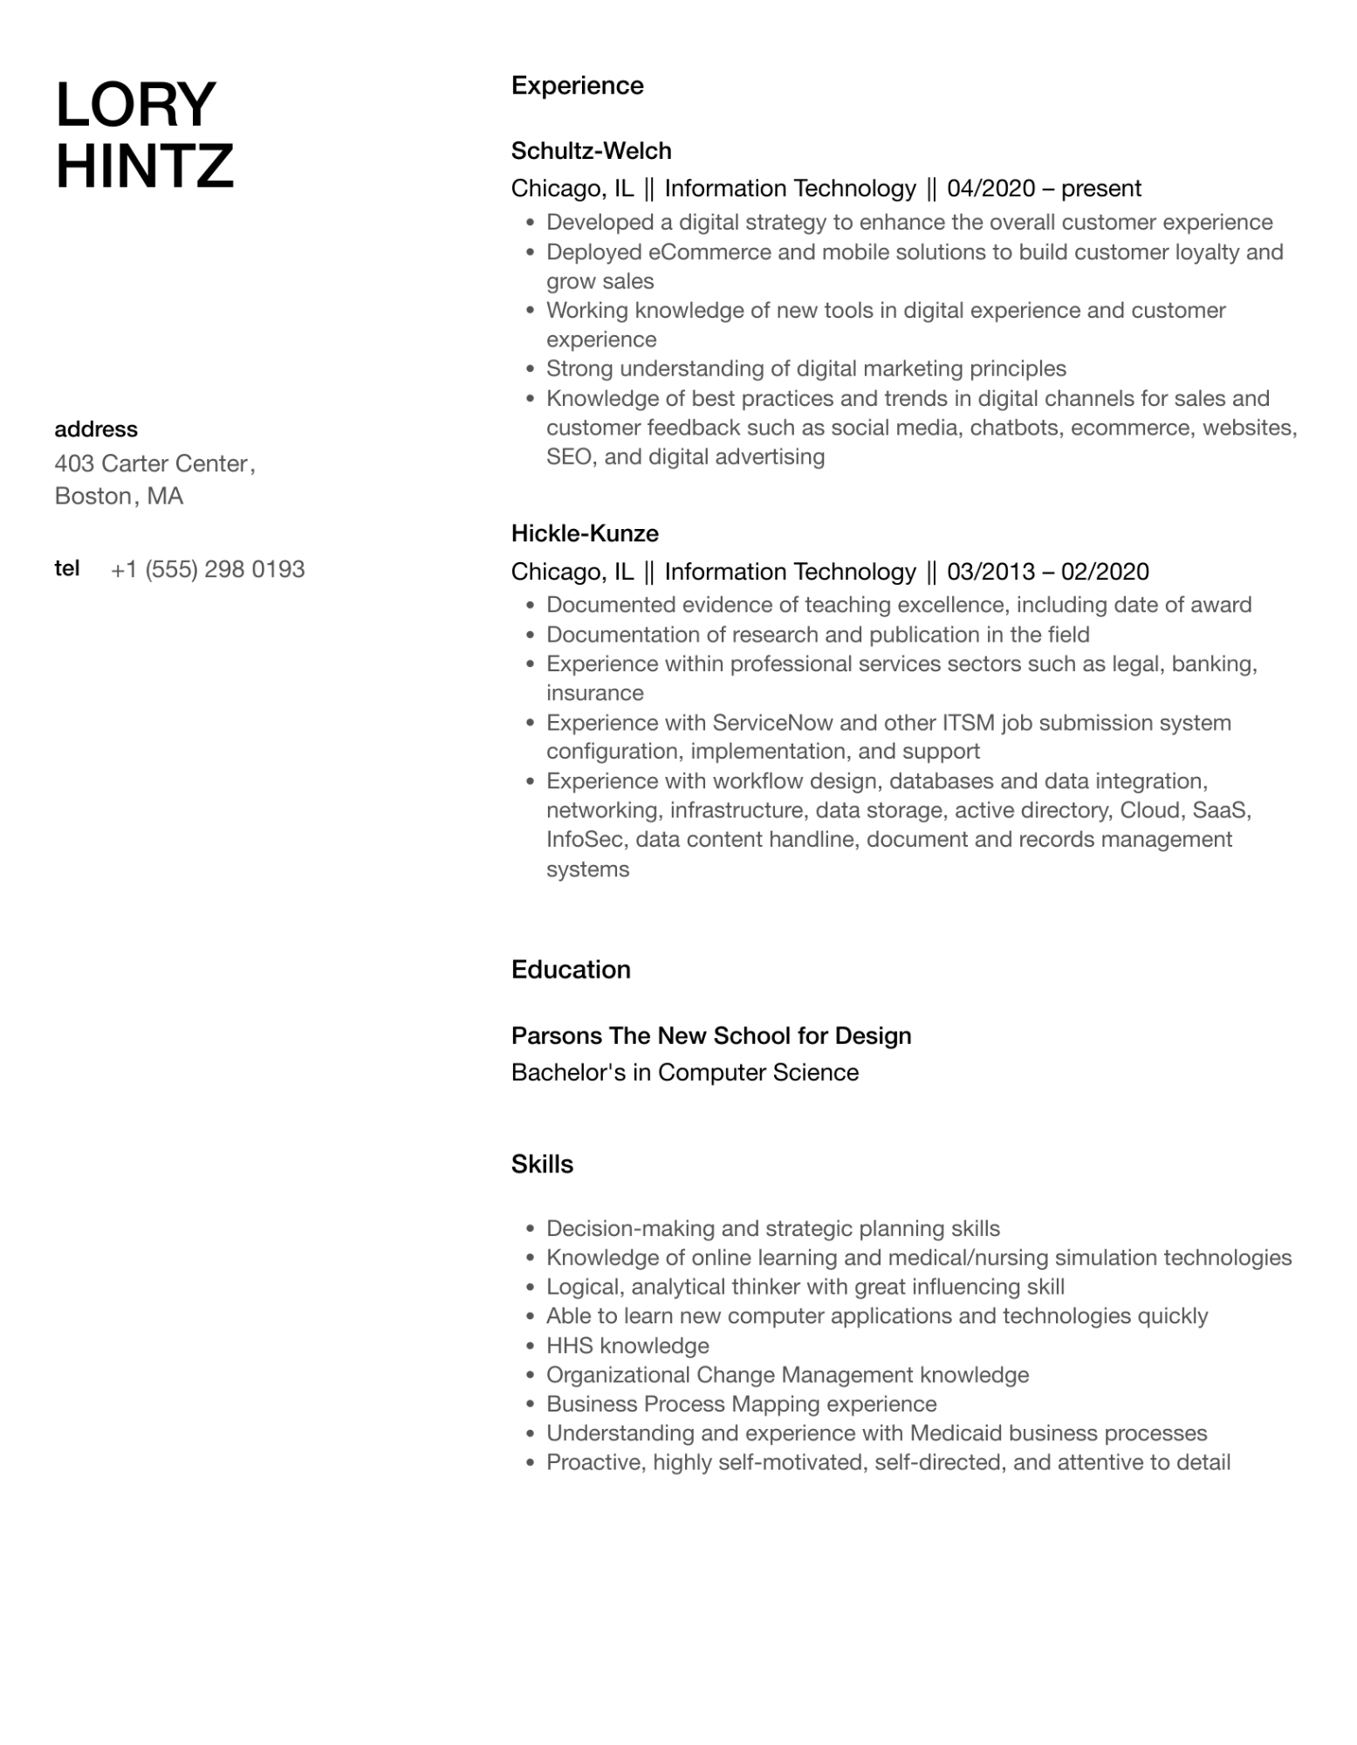
LORY HINTZ
Experience
Schultz-Welch
Chicago, IL || Information Technology || 04/2020 – present
•
•
·
•
•
Developed a digital strategy to enhance the overall customer experience Deployed eCommerce and mobile solutions to build customer loyalty and grow sales
Working knowledge of new tools in digital experience and customer experience
Strong understanding of digital marketing principles
Knowledge of best practices and trends in digital channels for sales and customer feedback such as social media, chatbots, ecommerce, websites, SEO, and digital advertising
address
403 Carter Center, Boston, MA
tel
+1 (555) 298 0193
Hickle-Kunze
Chicago, IL || Information Technology || 03/2013 - 02/2020
• Documented evidence of teaching excellence, including date of award Documentation of research and publication in the field
•
·
•
•
Experience within professional services sectors such as legal, banking, insurance
Experience with ServiceNow and other ITSM job submission system configuration, implementation, and support
Experience with workflow design, databases and data integration, networking, infrastructure, data storage, active directory, Cloud, SaaS, InfoSec, data content handline, document and records management systems
Education
Parsons The New School for Design
Bachelor's in Computer Science
Skills
•
·
•
Decision-making and strategic planning skills
Knowledge of online learning and medical/nursing simulation technologies
Logical, analytical thinker with great influencing skill
• Able to learn new computer applications and technologies quickly
• HHS knowledge
·
Organizational Change Management knowledge
• Business Process Mapping experience
•
•
Understanding and experience with Medicaid business processes
Proactive, highly self-motivated, self-directed, and attentive to detail

